Project Implementation Screenshots
Cloud Logging Sink to BigQuery for Log Analytics

- BigQuery Tables
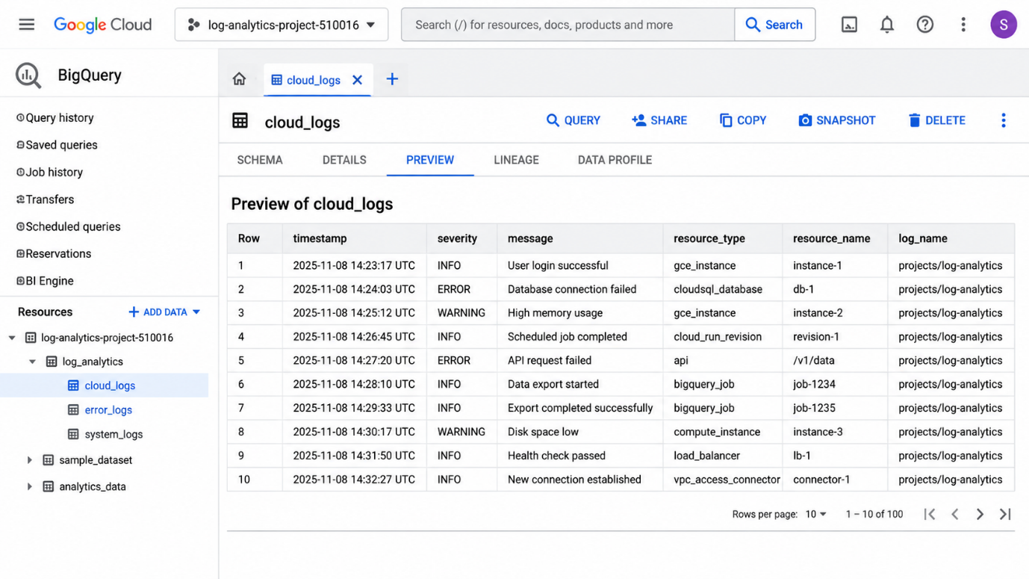
Shows the BigQuery dataset and sample log tables.

- Cloud Logs Explorer
Shows log entries with timestamps, severity levels, and messages.

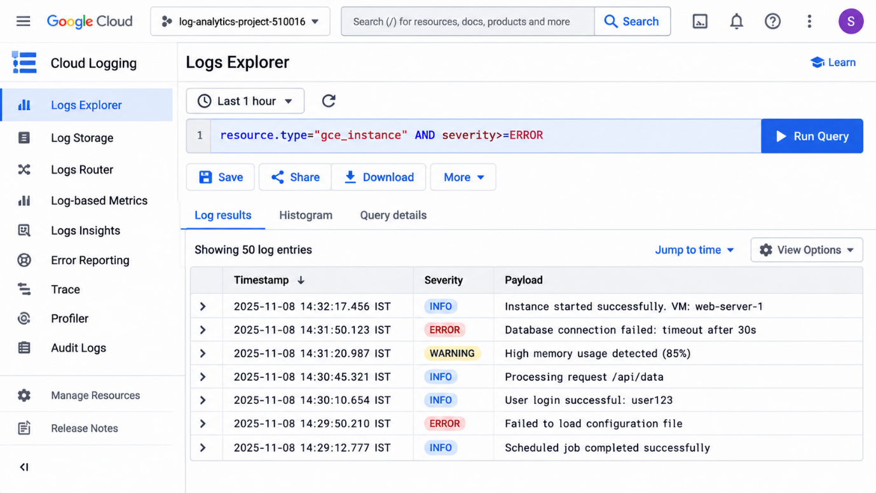
- SQL Analysis Results
Shows SQL queries used to analyse log records.
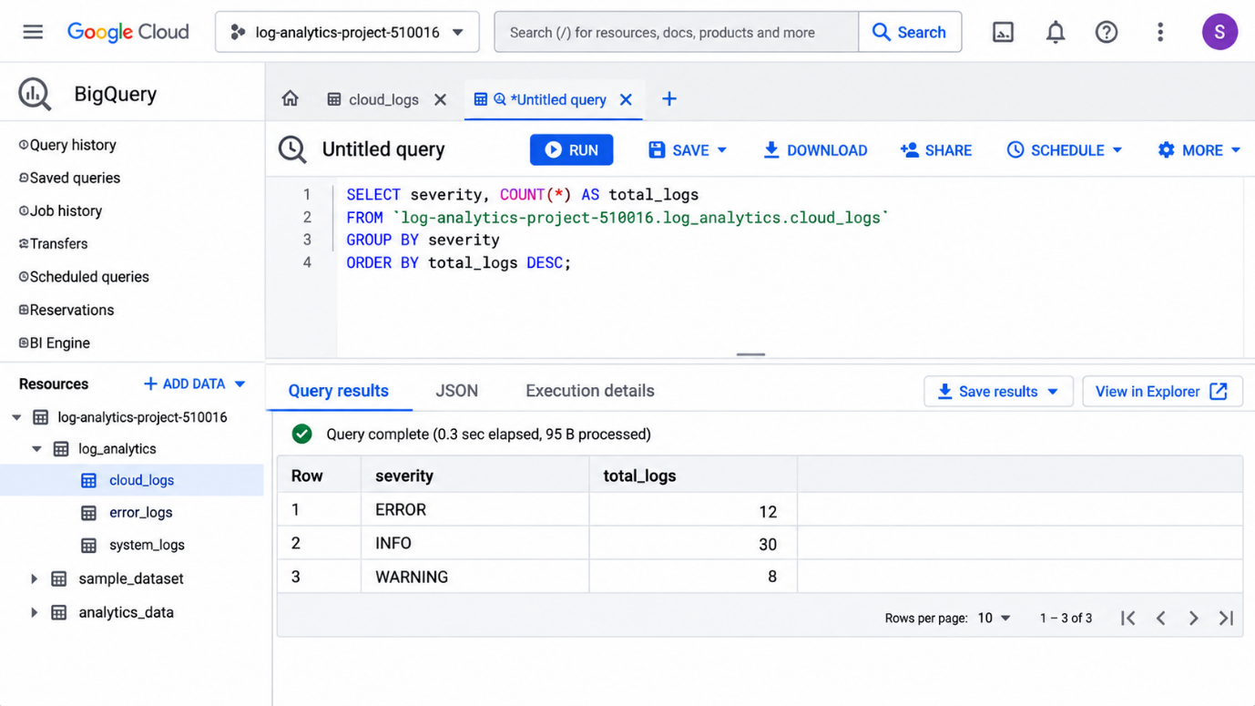
4. Log Severity Visualization
Shows a chart comparing ERROR, INFO, and WARNING log entries.

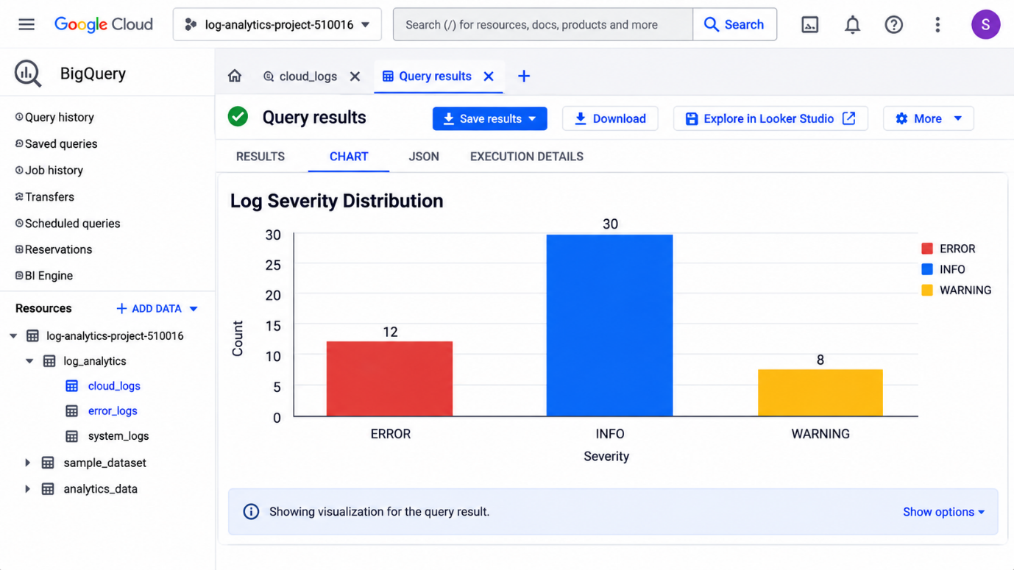
Purpose
These visual references explain the integration of Cloud Logging, Log Router, and BigQuery for log analytics.

